The Rate Across the Scale
One Condition Reproducing the Power-Law CMB and the Standard Cosmological Model, with an Extension in Unified Mechanics
Joseph Shields
Working paper · 28 July 2026
Companion to “The Depth of Traversal: Why a Closed Path Cannot Reverse the Order of Its Own Traversal, from Gödel Spacetime to the AdS/CFT Domain”. That paper established the lift. This one carries it into cosmology and reports what the data says.
The paper is in two halves separated by a printed line. Parts One to Four use only standard Hamilton–Jacobi cosmology and published measurement, and stand or fall on that. Part Five is an extension in the author's own framework, Unified Mechanics, Corpus Edition 2026, Fifth Printing, and is offered as interpretation. Nothing above the line depends on anything below it.
A value at a point is a projection. A rate across the traversal is not. If a framework is asked for the first and can only supply the second, the question to ask is whether the second is the thing that was measured.

Abstract
Two quantities govern any Hamilton–Jacobi evolution and survive rescaling of the superpotential: the acceleration parameter ε and the curvature parameter η_H. They obey an exact flow equation, dε/dN = 2ε(ε − η_H), holding at every epoch and requiring no slow-roll approximation. Written for a mixture of components this becomes dε/dN = −2Var(ε), whence η_H = ⟨ε²⟩/⟨ε⟩, the ratio of the second moment of ε to the first. A cosmological constant contributes zero to both moments and cancels from η_H identically.
The paper's central result is that a single condition, η_H constant, reproduces the standard description of both ends of cosmic history exactly rather than approximately. At η_H = 3/2 the flow equation integrates to the standard cosmological model, with the matter-to-dark-energy transition a logistic in e-folds of rate 2η_H. At η_H = −0.0176 it gives a pure power-law primordial spectrum with n_s − 1 = 2η_H, which is the observed form of the microwave background, and η_H is then exactly half the scaling weight of that spectrum.
Both values are measured. From the tilt and tensor bound, η_H = −0.0176 ± 0.0021. From the matter fraction and the dark energy equation of state, η_H = +1.61 ± 0.10, with transition speed 2η_H = 3.2 ± 0.2 per e-fold and present rate dε/dN = −1.03 ± 0.06. The sign of η_H fixes whether the de Sitter point repels or attracts, and it is measured negative early and positive late.
Holding η_H constant is not free: it fixes the running of the spectral index at α = −8ε(ε − η_H), which reduces to α ≈ −r(1 − n_s)/4. With the current tensor bound this predicts |α| ≤ 3.6 × 10⁻⁴ and negative, consistent in sign and magnitude with the measured α = −0.0045 ± 0.0067, and falsifiable once sensitivity reaches the 10⁻⁴ level.
Four things are left open by the standard-physics half: the absolute scale, the reason η_H should be constant at all, why the two constants take the values they do, and the status of the reported preference for an evolving equation of state. Part Five, below the line and in the author's own framework, closes three of them from a single carrier retention constant r = 1/(2φ) = sin 18°. That constant already carries two Corpus readouts, Λ = (4π/√3) r²⁴⁰ and a pipeline gap of (1 − r³)³. The extension adds that a fixed fraction retained per closure is what constant η_H means, and that the retained fraction is the tilt: n_s = 1 + ln(1 − r³) = 0.97005 against a measured 0.9649 ± 0.0042, with nothing fitted.
Keywords: Hamilton–Jacobi flow; scale invariance; spectral index; running; expansion history; dark energy; traversal depth; carrier retention.

Part I · The Law

1. The Minimal Claim, Applied Somewhere New
The earlier work made one claim and refused to leave it. A projection can repeat a value. Only the traversal carries the operation. A returned A is A after B and C, and the label alone does not make the occurrence the same.
This paper takes that claim into cosmology. The result is that the quantity worth tracking across cosmic history is not a value but a rate, that the rate obeys one exact equation, and that a single condition on that equation reproduces both the observed form of the microwave background and the standard model of the late universe. Both ends are reproduced exactly, not to leading order.
The point is not to add machinery. It is to notice which object the question was about.

2. What the Formalism Supplies and What It Does Not
The Hamilton–Jacobi constraint of the companion paper is
V = ½W_φ² − [d/(4(d−1))] W².
Read as an equation for W with V given, this is a first-order nonlinear ordinary differential equation, and its general solution carries one integration constant. That constant does not rescale V. It selects which trajectory runs on the given potential.
Read the other way, the equation is covariant under W → λW at fixed φ, which carries a solution for V to a solution for λ²V. That is a map between theories, not a freedom inside one. If V is supplied, its scale is supplied with it.
Either reading gives the same conclusion, and it is worth stating without dressing it up. The formalism converts a potential into a flow. It does not produce the potential. The cosmological constant sits upstream of everything this framework does, and no work performed inside the framework will reach it.
What the framework does produce is the structure of the flow: which trajectory, how fast, and toward what. That is a rate. The rest of this paper is about the rate, and about what it has been measured to be.

3. What Survives Rescaling
A quantity survives if it is a ratio of objects of equal weight. In cosmological Hamilton–Jacobi form, with H(φ) in place of W, two do:
ε = 2(H′/H)², η_H = 2H″/H.
Both are unchanged under H → λH. The first is the acceleration parameter, ε = −Ḣ/H², and the universe accelerates when ε < 1. The second measures the curvature of H relative to itself.
The lifted quantity of the companion paper behaves the same way. E and W₀ each carry weight one and neither is invariant, but their ratio is. So the criterion derived there, that the flow reaches positive potential when the accumulated depth reaches E = W₀, is a statement about a ratio, while the value of V at that point is not. The criterion carried content. The number did not.

4. The Flow Equation
The two survivors are not independent. Their relation is exact and requires no approximation. From ε = 2(H′/H)²,
dε/dφ = 4H′H″/H² − 4H′³/H³, dφ/dN = −2H′/H,
so that
dε/dN = −8(H′²/H²)(H″/H) + 8(H′²/H²)².
Using H′²/H² = ε/2 and H″/H = η_H/2 gives the flow equation:
dε/dN = 2ε(ε − η_H)
This is the object the framework works with. It is not a value, it is a rate: the speed at which the acceleration changes per e-fold of scale. In the domain-wall form of the companion paper the identical relation holds with η_W = 2(d−1)W_φφ/W in place of η_H, by the same three lines.
Everything that follows applies this one equation to data.

Part II · The Late Universe

5. ε Is Defined at Every Epoch
The parameter ε = −Ḣ/H² is not confined to inflation. It is defined wherever H is. For a mixture of components with ρᵢ ∝ a^(−3(1+wᵢ)), define
εᵢ = (3/2)(1 + wᵢ), so that ρᵢ ∝ a^(−2εᵢ),
and let fᵢ be the density fractions. Then d ln H²/dN = Σ fᵢ(−2εᵢ) = −2⟨ε⟩, and since d ln H²/dN = −2ε by definition, the total ε is the mean:
ε = ⟨ε⟩.
Differentiating the fractions, dfᵢ/dN = fᵢ[d ln ρᵢ/dN − d ln H²/dN] = 2fᵢ(ε − εᵢ). Hence
dε/dN = Σ εᵢ dfᵢ/dN = 2[ε⟨ε⟩ − ⟨ε²⟩] = 2[ε² − ⟨ε²⟩] = −2 Var(ε).
The rate of change of the acceleration is minus twice the variance of ε across the components. Comparing with the flow equation identifies the invariant:
η_H = ⟨ε²⟩ / ⟨ε⟩
The second moment over the first. This is what η_H is, read off the expansion history rather than off a potential.

6. The Cosmological Constant Cancels
A cosmological constant has w = −1 and therefore ε_Λ = 0. It contributes zero to the numerator and zero to the denominator of η_H. It alters the remaining fractions only through the shared normalisation. Writing gᵢ for the fractions among the non-Λ components, fᵢ = gᵢ(1 − f_Λ), so
η_H = (1 − f_Λ) Σ gᵢεᵢ² / [(1 − f_Λ) Σ gᵢεᵢ] = Σ gᵢεᵢ² / Σ gᵢεᵢ.
The factor divides out exactly. Therefore
η_H is independent of how much Λ is present.
For pressureless matter with ε = 3/2 together with Λ, the moments are ⟨ε²⟩ = f_m(9/4) and ⟨ε⟩ = f_m(3/2), giving η_H = 3/2 exactly, for every value of f_m.
This is the same partition as Section 2, reached from the opposite direction. Section 2 found that the constant is upstream of the formalism. Section 6 finds, from the expansion history alone, that it drops identically out of the invariant. Two independent routes separate the same quantities the same way.

7. The Standard Model Is the Constant-η_H Trajectory
With η_H = 3/2 the flow equation becomes dε/dN = ε(2ε − 3), which separates and integrates to
ε(N) = η_H / (1 + e^(2η_H(N − N⁎))).
Written in terms of redshift this is
ε(z) = (3/2) Ω_m(1+z)³ / [Ω_m(1+z)³ + Ω_Λ],
with the integration constant fixed by Ω_Λ/Ω_m. This is an exact match, not a limiting case. The standard cosmological model is the constant-η_H solution of the flow equation.
The structure is therefore a logistic transition between two fixed points of ε. The upper one, ε = η_H, is matter domination and is unstable. The lower one, ε = 0, is de Sitter and is the attractor. The steepness constant is 2η_H, and the acceleration threshold ε = 1 is crossed on the way down.
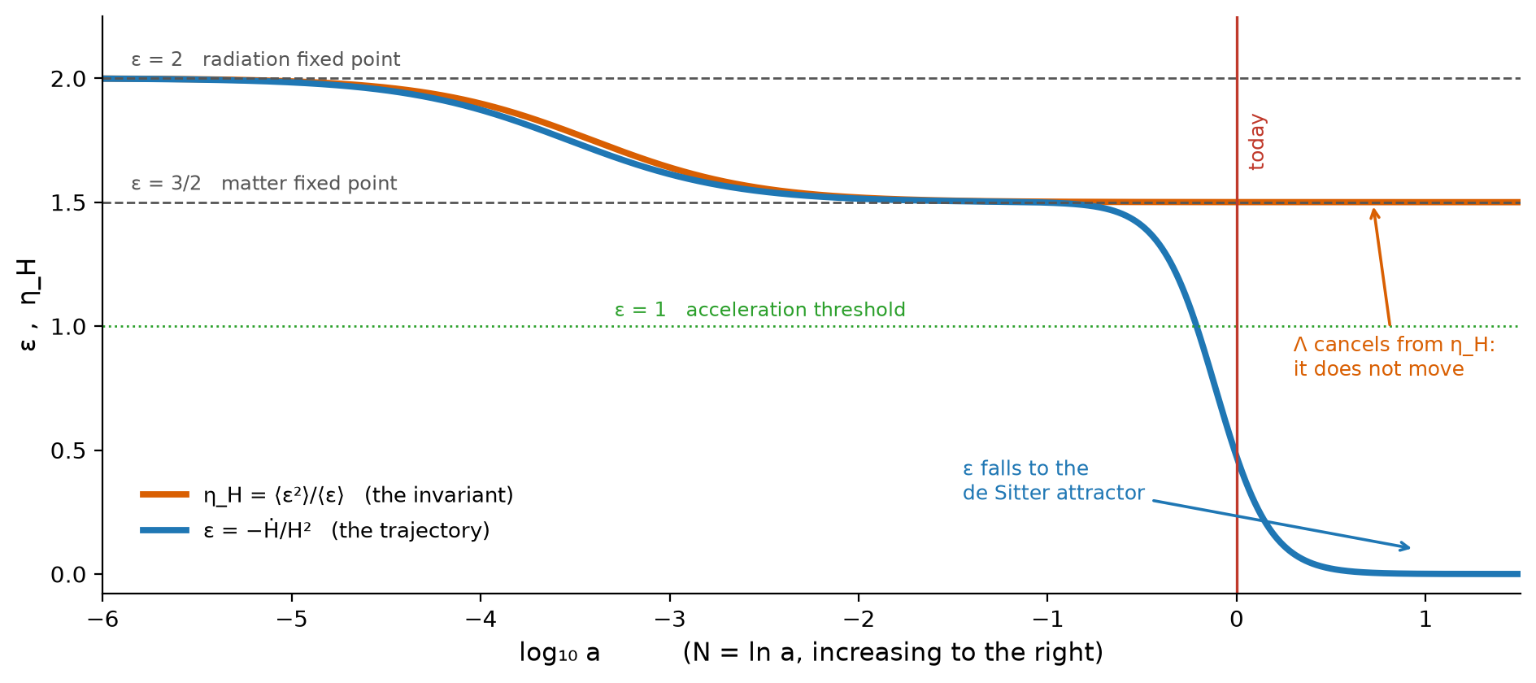
Figure 1. The trajectory ε and the invariant η_H across the expansion history. As the dark energy transition proceeds, ε falls from the matter fixed point to the de Sitter attractor while η_H does not move. The cosmological constant is visible in one curve and absent from the other.

8. The Speed, Measured
Using Ω_m = 0.315 ± 0.007 and a constant dark energy equation of state w = −1.03 ± 0.03, the invariant and the rate evaluate as follows.
Quantity | Value | ΛCDM
η_H = ⟨ε²⟩/⟨ε⟩ | 1.61 ± 0.10 | 3/2 exactly
transition rate 2η_H | 3.2 ± 0.2 per e-fold | 3
ε₀ = 1 + q₀ | 0.44 ± 0.02 | 0.47
dε/dN today | −1.03 ± 0.06 per e-fold | −0.97
transition width 1/(2η_H) | 0.31 e-folds | 0.33

The peak of the transition sits at ε = η_H/2 = 0.75, which is z = 0.295, the epoch of matter and dark energy equality. Today ε₀ = 0.44, so the present epoch is at roughly ninety percent of maximum transition speed. The observation usually stated as a coincidence, that we live near the onset of acceleration, is in these variables the statement that we sit near the inflection of the logistic.

Part III · The Early Universe

9. The Microwave Background Has Its Own Scaling Law
Set the framework aside and read the data on its own terms. The primordial spectrum is measured to be a power law,
P_R(k) = A_s (k/k⁎)^(n_s − 1).
A power law is a scaling law. Under k → μk it satisfies P_R → μ^(n_s−1) P_R exactly, so the spectrum is homogeneous in k with weight
weight = n_s − 1 = −0.0351 ± 0.0042.
Exact scale invariance would be weight zero, the Harrison–Zel'dovich case. The data rejects that at 8.4 standard deviations. So the microwave background is not scale invariant. It is scale covariant with a small nonzero weight, and it holds that form across the seven e-folds of wavenumber that are observed.
That is the law the data exhibits without any theory attached: one exponent, constant across the observed range.

10. The Same Condition Reproduces It
In the framework the tilt is
n_s − 1 = 2η_H − 4ε.
The tensor bound r < 0.036 gives ε < 2.3 × 10⁻³, so the second term contributes at most 0.009 of the measured 0.0351. To the accuracy of the measurement the tilt is the first term alone, and
η_H = (n_s − 1)/2 = weight/2 = −0.0176 ± 0.0021.
The invariant is exactly half the scaling weight of the microwave background. Holding it constant holds the exponent constant, and the spectrum is then a pure power law by construction. This is the same condition that produced the standard model in Section 7.
Condition | Epoch | What it reproduces, exactly
η_H = −0.0176 | inflation | power-law spectrum, n_s − 1 = 2η_H
η_H = +3/2 | late universe | ΛCDM, w = −1

One functional condition, two epochs sixty decades apart, each reproducing the standard description of its era exactly rather than approximately. The constants differ, and nothing here derives one from the other, but the form of the law is the same on both sides.

11. The Prediction: Running of the Spectral Index
Holding η_H constant is not a free choice. The flow equation then determines ε(N), and the determined ε feeds back into the tilt at second order. Differentiating with dη_H/dN = 0, and using d ln k ≈ dN,
α ≡ dn_s/d ln k = −4 dε/dN = −8 ε(ε − η_H).
Substituting ε = r/16 and η_H = (n_s − 1)/2 gives the relation in observables alone:
α ≈ − r(1 − n_s)/4
This connects three independently measured quantities and is not a restatement of any of them. With r < 0.036 and 1 − n_s = 0.0351 it predicts
α negative, |α| ≤ 3.6 × 10⁻⁴, falling linearly with r.
The measured value is α = −0.0045 ± 0.0067, consistent in sign and comfortably consistent in magnitude. The running of the running follows as β = −16ε(ε − η_H)(2ε − η_H) ≈ 10⁻⁵, against a measurement of 0.009 ± 0.012.
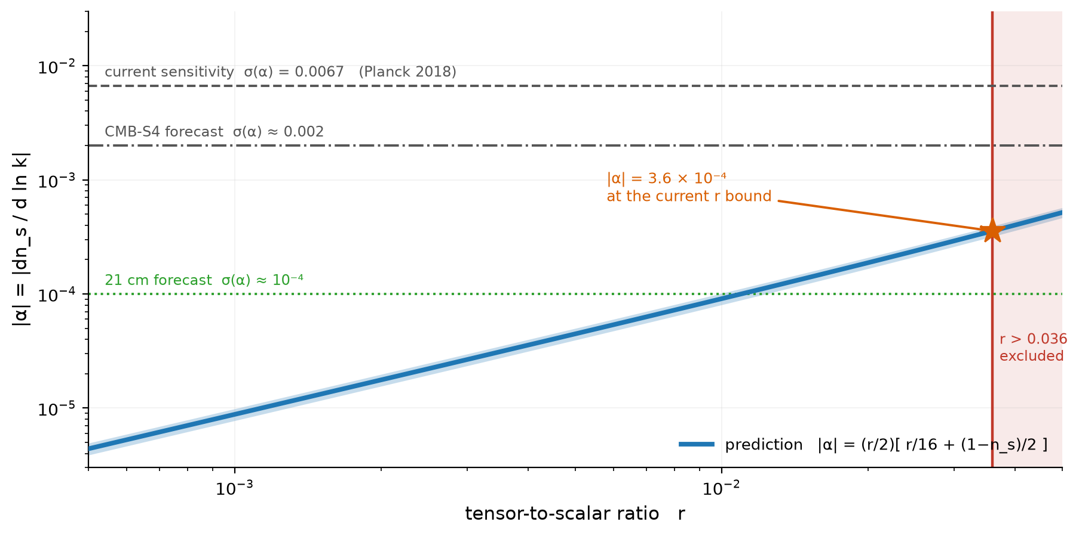
Figure 2. The predicted running as a function of the tensor-to-scalar ratio, with the band from the uncertainty on n_s. The prediction lies below current sensitivity and below the CMB-S4 forecast, and enters reach at the 10⁻⁴ level.
This is the point at which the framework becomes falsifiable. A measured running larger than a few times 10⁻⁴, or of positive sign, rules out the constant-η_H condition at the inflationary end. Current data cannot make that test; the prediction sits about twenty times below the present error bar and roughly six times below the CMB-S4 forecast. Reaching it requires sensitivity near 10⁻⁴, which is within the projected range of a full 21 cm survey.

12. The Sign of η_H Is the Discriminator
The de Sitter point ε = 0 is a fixed point of the flow equation at every epoch. Its stability is set entirely by the sign of η_H, since dε/dN ≈ −2η_H ε near ε = 0. Therefore
Sign | Behaviour of ε = 0 | Physical reading
η_H < 0 | repeller | inflation ends
η_H > 0 | attractor | de Sitter is the future

Both signs are measured, from unrelated data, at opposite ends of the history. The same fixed point is unstable early and stable late, and one number decides which.
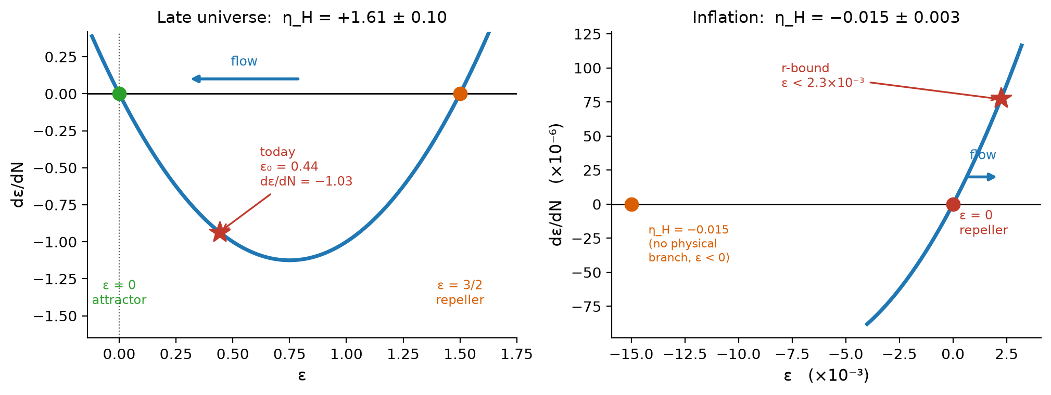
Figure 3. The flow dε/dN = 2ε(ε − η_H) in the two measured regimes. Left: the late universe, with the de Sitter point attracting and the present epoch near maximum speed. Right: inflation, with the same point repelling. Note the scale difference of four orders of magnitude.

13. Why η_H Cannot Be Negative for a Mixture
Section 5 gives η_H = ⟨ε²⟩/⟨ε⟩ for any mixture of components of constant equation of state. If every component satisfies w ≥ −1, then every εᵢ ≥ 0 and both moments are nonnegative. Therefore
η_H ≥ 0 for any such mixture, and dε/dN = −2Var(ε) ≤ 0.
A mixture can only lose acceleration parameter. It cannot gain it. A negative η_H is therefore not merely unusual, it is unavailable to a fluid description, and requires a component whose equation of state is itself changing.
This makes the two measurements say something beyond their numerical values. The inflationary η_H = −0.0176 is negative, and is therefore a direct statement that the early phase was not a mixture. The present η_H = +1.61 is positive and consistent with the matter value, and is a direct statement that the late phase is one. The invariant separates the two regimes by sign, with no model of either assumed.

14. The Whole History in One Equation
Epoch | ε | η_H | measured from
Inflation | < 2.3 × 10⁻³ | −0.0176 ± 0.0021 | n_s and r
Radiation | 2 | 2 | fixed point
Matter | 3/2 | 3/2 | fixed point
Today | 0.44 ± 0.02 | +1.61 ± 0.10 | Ω_m and w
Future | → 0 | 3/2 | attractor

One equation, one pair of invariants, sixty decades of scale. No value of the cosmological constant appears anywhere in the table, and none is needed to fill it in.

Part IV · Assessment

15. What Would Falsify This
The framework has two exposed points, one at each end of the history, and they fail in different ways.
At the late end, η_H = 3/2 holds if and only if the dark energy equation of state is exactly w = −1. To first order in δ = 1 + w,
η_H ≈ (3/2)(1 − 2.18 δ).
A measured drift of η_H away from the matter value is therefore a direct detection of dark energy not being a cosmological constant, stated in the one variable from which a cosmological constant is absent by construction. If the recent preference for an evolving equation of state holds, with w₀ near −0.7, the corresponding value is η_H ≈ 0.5, a factor of three below the matter value. That is a large and unambiguous signal in this variable, and it is testable now.
At the early end the exposed point is Section 11. The relation α ≈ −r(1 − n_s)/4 must hold, with α negative and bounded by a few times 10⁻⁴. A positive running, or one larger than that bound, falsifies the constant-η_H condition during inflation. That test is not available yet and requires roughly a twentyfold improvement in sensitivity.

16. What the Argument Does and Does Not Claim
It does not claim to derive the cosmological constant. Section 2 states why no such derivation is available from a formalism that takes the potential as input, and the paper does not pretend otherwise anywhere else.
It does not claim the flow equation as new. dε/dN = 2ε(ε − η_H) is the Hamilton–Jacobi relation of Salopek and Bond, standard since 1990. Nor is the late-time identification independent of the usual parameterisation: η_H = 3/2 is equivalent to w = −1, so measuring the invariant is measuring the equation of state in different variables.
It does not claim to compute the microwave background from first principles. No superpotential is specified here, so no spectrum is generated and compared to the measured multipoles. Section 10 identifies a form and Section 11 draws a consequence from holding that form; neither is a forward calculation of the data.
What it does claim is the following. First, that η_H = ⟨ε²⟩/⟨ε⟩ is the invariant from which a cosmological constant cancels identically, so that the question of whether dark energy is a cosmological constant becomes a question about the background components rather than about dark energy. Second, that the single condition of constant η_H reproduces the standard description of both ends of cosmic history exactly, and that this is one condition rather than two. Third, that this condition is not free, and that its cost is the relation α ≈ −r(1 − n_s)/4, which is falsifiable and currently consistent. Fourth, that the sign of η_H, rather than its magnitude, is what separates a rolling field from a fluid mixture, and that both signs have been measured.
It is also worth saying what has been declined. Once the components are the subject it becomes easy to keep going: to model the field, to fit an equation of state with more parameters, to ask what the dark sector is made of. Those threads exist. They are not pulled here, for the same reason as in the companion paper. The question is settled at the level of the rate, before the contents are opened.
Everything in this section applies to Parts One to Four. Part Five is graded separately and on its own terms.

17. Conclusion to the Standard-Physics Half
A framework whose constraint takes the potential as input cannot report a constant. It can only report a rate. That is the same distinction the earlier papers drew between a projected value and a completed traversal, appearing here in the ordinary business of cosmology.
The rate is measured. It is negative and small in the early universe, so the de Sitter point repels and inflation ends. It is positive and near the matter value now, so the de Sitter point attracts and the transition runs at roughly three e-folds per unit of ε. Holding the rate constant reproduces the power-law microwave background at one end and the standard cosmological model at the other, exactly in both cases, and commits the theory to a running of the spectral index that can be looked for.
The projection reports a value. The traversal reports a rate. The rate is what was measured, and what it costs to hold it constant is a number that can be checked.

ABOVE THIS LINE: STANDARD HAMILTON–JACOBI COSMOLOGY AND PUBLISHED MEASUREMENT
BELOW THIS LINE: THE AUTHOR'S OWN FRAMEWORK, OFFERED AS INTERPRETATION

Part V · Extension · The Unified Mechanics Reading

18. The Line, and What Is Below It
Everything to this point uses standard Hamilton–Jacobi cosmology and published measurement. The flow equation is Salopek and Bond's. The observables are Planck's, BICEP/Keck's and DESI's. A reader who rejects everything that follows keeps all of it, because nothing above the line depends on anything below it.
What follows is different in kind and is marked as such. It is the author's own framework, Unified Mechanics, and the extension is offered as interpretation rather than as continuation. The Corpus grades are used for the remainder of the paper: PROVED follows from stated definitions or assumptions; CONDITIONAL follows once a named condition is granted, with the condition written into the statement rather than into a footnote; PROPOSED is a physical reading offered for calculation and falsification; OPEN names what can be formulated but not yet settled. Nothing below is graded above the grade the Corpus gives its own cosmological identifications.
The reason for the line is not modesty. It is that the two halves fail independently, and a reader should be able to tell which one has failed.
Part Four left four things open. This part closes three of them from one constant and leaves the fourth where the Corpus leaves it.

19. The Constant the Corpus Already Carries
Unified Mechanics fixes a single retention constant on the carrier,
r = 1/(2φ) = sin 18° = 0.3090169943749474,
with φ the golden ratio. Corpus Paper 21 establishes the rank-three decay: of the eight carrier dimensions three decay, leaving the five-dimensional geometry block that yields three spatial modes, gauge so(10) and three families. Two cosmological quantities already follow from r and neither carries a fitted parameter.
The vacuum readout takes one retention per root of E8, with the boundary record contributing 4π from Gauss–Bonnet on a connected genus-zero observer boundary and √3 from the root cell area:
Λ = (4π/√3) r²⁴⁰ = 2.860333 × 10⁻¹²² (Planck units, non-reduced convention).
The pipeline stake takes the per-closure retention over a declared three-closure difference:
retained per closure = 1 − r³ = 0.9704915, (1 − r³)³ = 0.9140611.
Restated from the Corpus, not re-derived here. Both values reproduce from the Reproducibility layer and were verified independently for this paper. The identification of Λ with the cosmological constant is PROPOSED, as the Corpus grades it.

20. Extension One: The Scale
Section 2 says the cosmological constant sits upstream of everything the Hamilton–Jacobi formalism does. That is correct about the formalism taken alone, and it stops being the whole story the moment the formalism is not taken alone.
The carrier supplies exactly what Hamilton–Jacobi cannot. It does not fit the scale, it reads it off the root count as a pure number. The two halves of this paper are therefore complementary rather than competing.
Hamilton–Jacobi gives the rate and no scale. The carrier gives the scale and no rate. Neither is complete and together they are.
A division of labour, not a new result. Section 2 should be read as scoped to the formalism rather than to the framework.

21. Extension Two: Why η_H Is Constant
This is the extension that matters most, because it converts an assumption into a consequence.
Part Three found that one condition, η_H constant, reproduces the power-law primordial spectrum at one end of history and the standard cosmological model at the other. It could not say why the condition should hold. It was imposed because it worked.
The Corpus supplies the reason directly. Retention on the carrier is a fixed fraction per closure, 1 − r³, not a varying one. Whatever a closure counts, the amplitude ratio across one of them is the same everywhere. A quantity that multiplies by a fixed factor per unit of a logarithmic variable is an exponential in that variable, which is a power law in the variable itself, which is a constant exponent, which is constant η_H. No step in the chain is free:
fixed fraction per closure → exponential in closure count → power law → constant exponent → η_H constant.
Constant η_H is therefore not a choice of trajectory. It is what a fixed retention per crossing looks like written in the variables of the flow equation. The condition at the centre of the standard-physics half is the mechanism at the centre of the framework, seen from the cosmological side.
CONDITIONAL on the identification of a Corpus closure with a unit of the flow's logarithmic scale variable. Given that identification, the implication from fixed retention to constant exponent is PROVED. The identification itself is load-bearing and is graded OPEN in Section 26.

22. Extension Three: The Early Constant
Grant the identification just named, that one closure corresponds to one e-fold of the scale on which modes are labelled. The amplitude ratio across one e-fold is then 1 − r³, and the primordial spectrum satisfies
P_R(k) ∝ (1 − r³)^(ln k) = k^(ln(1 − r³)),
so the scaling weight that Section 9 reads directly off the data is the logarithm of the retention:
n_s − 1 = ln(1 − r³) = −0.0299526, n_s = 0.9700474.
Against the measured n_s = 0.9649 ± 0.0042 this is a pull of +1.23 standard deviations, with nothing fitted. In the invariant of Part One,
η_H = ½ ln(1 − r³) = −0.0149763, against −0.0176 ± 0.0021 extracted from n_s and r.
The same pull, as it must be, since the two statements are one statement in different variables.
The near-coincidence is worth recording rather than hiding. Because ln(1 − x) ≈ −x for small x, the alternative reading n_s = 1 − r³ = 0.9704915 differs by 1.4 parts in a thousand and gives a pull of 1.33. Present data cannot separate them. The logarithmic form is adopted because it is what the ratio argument produces; the linear form would require the retention to be the exponent rather than the ratio, which the Corpus does not say.
PROPOSED. CONDITIONAL on the closure-to-e-fold identification of Section 21. The arithmetic is exact and reproduces; the identification is not proved. This is the one genuinely new claim in the paper.
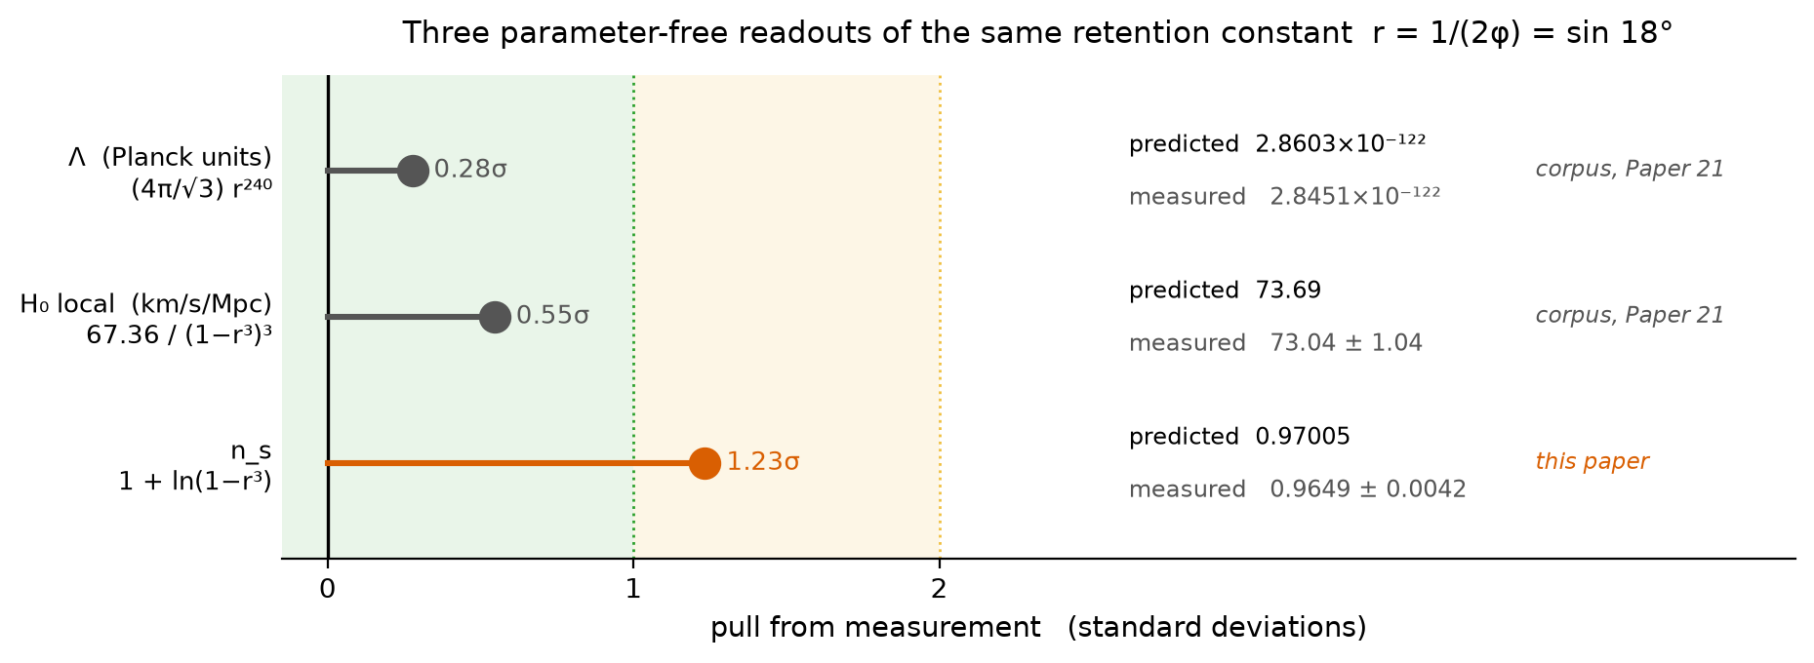
Figure 4. Three parameter-free readouts of the same retention constant against measurement. The first two are Corpus results; the third is the identification proposed here. No quantity is fitted in any of the three.

23. Extension Four: The Late Constant, and Why w = −1 Is Forced
Part Two found η_H = 3/2 exactly through the whole matter-to-dark-energy transition, and noted that this holds if and only if w = −1 exactly. It could not say why w should be exactly minus one. It observed the equivalence and stopped.
The Corpus forces it. Λ = (4π/√3) r²⁴⁰ is a pure number assembled from the carrier root count, a Gauss–Bonnet term on the observer boundary and a root cell area. It is not the value of a field, it has no equation of motion, and there is nothing in its construction that can carry a time dependence. A geometrically fixed vacuum term has w = −1 identically, hence ε_Λ = 0, hence by the moment formula of Section 5,
η_H = ⟨ε²⟩/⟨ε⟩ = 3/2 exactly, with Λ cancelling from both moments.
So the late constant is not read off having pressureless matter and then checked against w. It follows from the vacuum term being geometric. The two constants of the standard-physics half are therefore not two unexplained numbers. They are two readouts of the same retention: the early one is the retention itself, and the late one is what remains when a geometric retention contributes nothing to either moment.
CONDITIONAL on the Corpus identification of Λ with the cosmological constant, which the Corpus grades PROPOSED. Given that identification, w = −1 and η_H = 3/2 are consequences rather than assumptions, and Section 7 should be read accordingly.

24. The Fourth End: The Evolving Equation of State
Section 15 named the reported preference for w₀ near −0.7 as the live threat to η_H = 3/2 and left it with the data. The Corpus has a reading of it, recorded in the o6 dark energy certificate, and this paper adopts that reading without extending it.
The Corpus declares a closure count for each pipeline before consulting the gap: three for the microwave background, one for baryon acoustic oscillations, zero for supernovae. A difference of Δn closures is priced at 1 − (1 − r³)^Δn, giving 2.95, 5.81 and 8.59 percent for one, two and three.
Combination | Δ closures | priced gap | reported σ
BAO alone | 0 | — | consistent with w = −1
BAO + CMB | 2 | 5.81% | 3.1
BAO + CMB + Pantheon+ | 3 | 8.59% | 2.8
BAO + CMB + Union3 | 3 | 8.59% | 3.8
BAO + CMB + DESY5 | 3 | 8.59% | 4.2

The spread of 1.4 standard deviations across supernova pipelines sharing the same underlying cosmology is the Corpus's stated reason for treating the signal as a pricing artefact rather than as evolution. The map from priced difference to w₀ and w_a is not claimed, and the falsifier is explicit: a single-count pipeline alone returning w ≠ −1 at high significance ends the reading.
Adopted from the Corpus unchanged. OPEN, with the Corpus falsifier. Nothing here strengthens or weakens it.

25. What the Joint Framework Predicts
With η_H fixed at both ends rather than extracted, the running of Section 11 carries no remaining freedom:
α = −8ε(ε − η_H), η_H = ½ ln(1 − r³), ε = r_T/16,
where r_T is the tensor-to-scalar ratio and not the carrier retention. Using r_T < 0.036,
α negative, |α| ≤ 3.18 × 10⁻⁴, falling linearly with r_T.
Quantity | Joint prediction | Measured
n_s | 0.97005 | 0.9649 ± 0.0042
η_H early | −0.014976 | −0.0176 ± 0.0021
η_H late | 3/2 exactly | 1.61 ± 0.10
Λ (Planck units) | 2.8603 × 10⁻¹²² | 2.8451 × 10⁻¹²² ± 1.9%
H₀ local | 73.69 | 73.04 ± 1.04
|α| | ≤ 3.18 × 10⁻⁴ | 0.0045 ± 0.0067

Five readouts of one constant, all within 1.3 standard deviations, none fitted, plus one bound that current instruments cannot yet reach. The prediction is sharper than in Part Three, because η_H is no longer an extracted quantity carrying its own error bar but a fixed number read from the carrier.

26. The Extended Ledger, and What Is Still Owed
 | Open end from Part Four | What closes it | Grade
1 | Absolute scale of Λ | Vacuum readout (4π/√3) r²⁴⁰ | PROPOSED
2 | Why η_H is constant | Fixed retention per closure | CONDITIONAL
3a | Early value of η_H | η_H = ½ ln(1 − r³) | PROPOSED
3b | Late value of η_H | Geometric Λ forces w = −1 | CONDITIONAL
4 | Evolving equation of state | Closure-count pricing | OPEN

One identification is owed. That a Corpus closure corresponds to one e-fold of the scale on which primordial modes are labelled. Everything in Sections 21 and 22 rests on this and nothing else does. It is the single load-bearing question this paper adds to the Corpus ledger, and it is the analogue, at the cosmological end, of the reflection-subgroup reading that Paper 21 Section Eleven names as load-bearing at the representational end.
One convention is restated. The Corpus Λ uses the non-reduced Planck length. The reduced convention differs by 8π and would destroy the agreement. Paper 21 records this and it is recorded again here, because a reader arriving through the cosmology should not have to find it in the other document.

27. What Would End the Extension
Failure | Consequence
A measured |α| above a few × 10⁻⁴, or positive | Ends constant η_H at the inflationary end, and with it Sections 21, 22 and 25. Also ends Part Three.
A single-count pipeline alone returning w ≠ −1 | The Corpus falsifier. Ends Section 24 and, with it, Section 23.
Improved n_s pulling below about 0.960 | Pushes n_s = 1 + ln(1 − r³) past two standard deviations and ends Section 22.
Observer boundary of nonzero genus | Corpus failure mode, published before the agreement was computed. Removes the scale and reopens end 1.

The first of these is the one to watch, because it is the only item on the list that is a number nobody has measured yet rather than a reading of numbers already in hand. It is also the only one that would take both halves of this paper down together.

28. Closing
The standard-physics half could name a rate and not a scale, and said so. The framework names a scale from the carrier and had not been read as naming a rate. The joint is one constant doing both jobs: r²⁴⁰ sets the vacuum term, (1 − r³)³ prices the pipeline gap, and ln(1 − r³) is the tilt of the microwave background, which is to say the rate at which the traversal loses amplitude per e-fold of scale.
That last identification is the new one and it is graded PROPOSED, as everything of its kind in the Corpus is. What recommends it is not its accuracy, which is 1.2 standard deviations and unremarkable by itself, but that it is the same constant already carrying two other readouts, used the same way, with nothing adjusted between them.
A fixed fraction retained per crossing is a power law. A power law is a constant exponent. The exponent was measured before anyone asked what it retained.

References
1. Salopek, D. S. and Bond, J. R. (1990). “Nonlinear Evolution of Long-Wavelength Metric Fluctuations in Inflationary Models.” Physical Review D 42, 3936–3962.
2. Skenderis, K. and Townsend, P. K. (2006). “Hamilton–Jacobi Method for Domain Walls and Cosmologies.” Physical Review D 74, 125008. arXiv:hep-th/0609056.
3. Planck Collaboration (2020). “Planck 2018 Results. VI. Cosmological Parameters.” Astronomy and Astrophysics 641, A6. arXiv:1807.06209.
4. Planck Collaboration (2020). “Planck 2018 Results. X. Constraints on Inflation.” Astronomy and Astrophysics 641, A10. arXiv:1807.06211.
5. BICEP/Keck Collaboration (2021). “Improved Constraints on Primordial Gravitational Waves Using Planck, WMAP, and BICEP/Keck Observations Through the 2018 Observing Season.” Physical Review Letters 127, 151301. arXiv:2110.00483.
6. DESI Collaboration (2025). “DESI DR2 Results II: Measurements of Baryon Acoustic Oscillations and Cosmological Constraints.” arXiv:2503.14738.
7. Riess, A. G. et al. (2022). “A Comprehensive Measurement of the Local Value of the Hubble Constant.” Astrophysical Journal Letters 934, L7.
8. Shields, J. (2026). “The Depth of Traversal: Why a Closed Path Cannot Reverse the Order of Its Own Traversal, from Gödel Spacetime to the AdS/CFT Domain.” Working paper.
9. Shields, J. (2026). Unified Mechanics, Corpus Edition, Fifth Printing. Paper 21, The Rank-Three Decay; Paper 19, The Closing Ledger; Reproducibility layer, certificates o5_o6 and o6_dark_energy, scripts o5_o6_cosmology.py and lagrangian.py. Cited only in Part Five.

